According to one popular tale, Captain chooses “Archi” a Oraon trible village as head quarter. Archi mean Bamboo forest in local Nagpuri dialect. The British inadvertently named “Archi” as “Ranchi”. Ranchi is the capital of the Indian state of Jharkhand. Ranchi was the center of the Jharkhand movement which called for a separate state for the tribal regions of south Bihar, northern Orissa, western West Bengal and the Eastern area of what is present day Chhattisgarh. The Jharkhand state was formed on 15 November 2000 by carving out the Bihar divisions of Chota Nagpur and Santhal Paraganas. Ranchi has been selected as one of the hundred Indian cities to be developed as a smart city under flagship smart cities mission.
As of 2011 India census, Ranchi Municipal Corporation has a population of 1,073,427, making it the 46th largest urban city in India. Males constitute 52.1% of the population and females 47.9%. Ranchi has an average literacy rate of 87.68%.
Summer temperatures range from 20 °C to 42 degrees, winter temperatures from 0 °C to 25 degrees. December and January are the coolest months, with temperatures dipping to the freezing point in some areas (kanke). The annual rainfall is about 1430 mm.
Ranchi has 24*7 Roads, Rail, and Air Connectivity.
Ranchi has plenty of hotels including five star Hotels.
Nigam Park
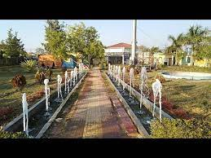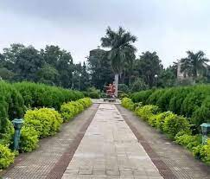
Contact any Queries for booking this place.
Contact Details: Md Ejaz
Contact Number: 6204638771
Email: mdejaj001ejaj@gmail.com

Morabadi Children Park (Shaheed Sankalp Park)

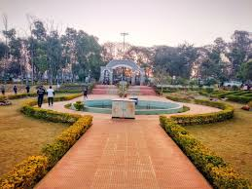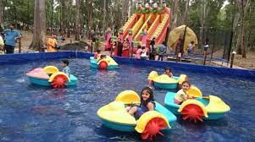

Contact any Queries for booking this place.
Contact Details: Ashutosh Kumar
Contact Number: 7004181859
Email: vyalisolution@gmail.com

Sector VII Park.

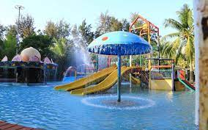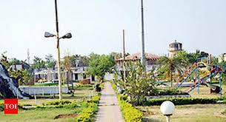

Contact any Queries for booking this place.
Contact Details: Yogesh Srivastav
Contact Number: 9430322101
Email: parkgreen9@gmail.com

Shree Krishna Singh park.

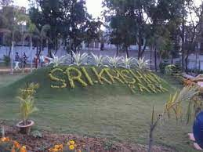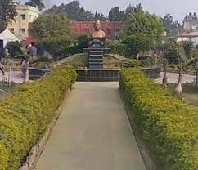

Contact any Queries for booking this place.
Contact Details: Gautam Jaiswal
Contact Number: 9431103858
Email: gauti0012@gmail.com

Shahid Vijay Soreng Park Dhurwa.

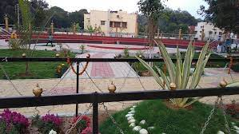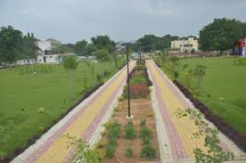

Contact any Queries for booking this place.
Contact Details: Ashutosh Kumar
Contact Number: 7004181859
Email: vyalisolution@gmail.com

Permission and Fee Details.
Fee: A sum of Rs. 25000/- is charged for 8 hours. However the charges subjected to change according to the allotment hours.

Permission Authority: Municipal Commissioner Ranchi
Email: support@ranchimunicipal.com
Telephone: 06512203469

